Institute of Computer Technology

B. Tech Computer Science and Engineering

Subject: Basics Of Communication Systems (2CSE202)

PRACTICAL - 6

AIM: To apply static and RIP routing

* Let us first understand STATIC routing
* I have made this type of topology as mentioned below

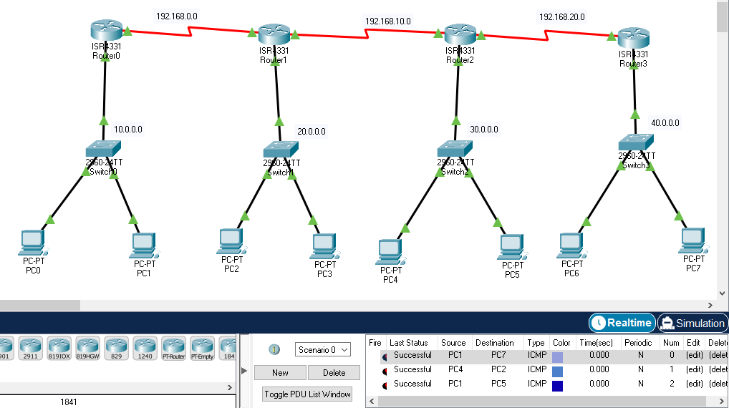

It has been successful.

Step 1: choose 4 routers and switches and pcs connect them as usual

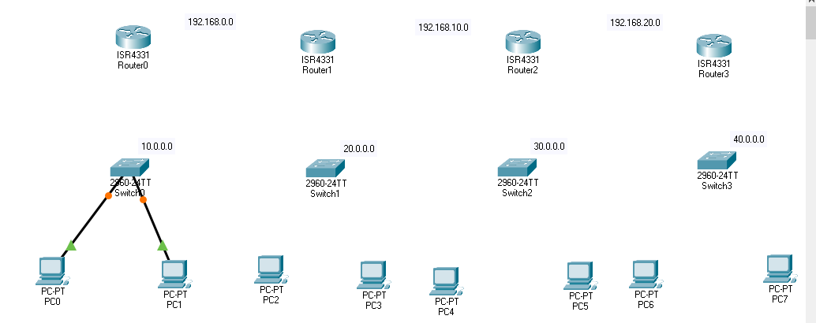

Now connect gigabyte0/0/0 interface to each of router from switch (fastethernet)

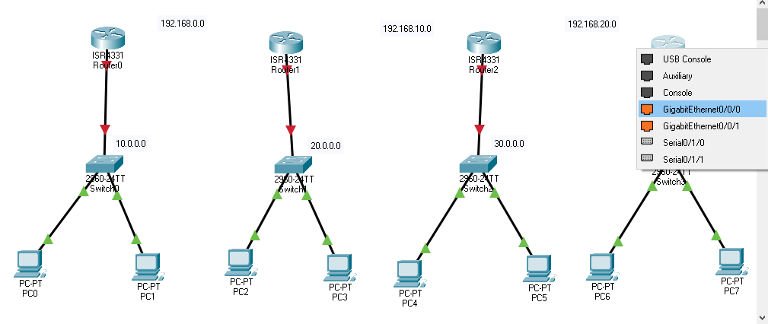

Now to connect all routers we will use serial port for that we need to add it separately because this port is not available for that go to router 5 and add that turn off it and then add it then turn on it.

Turn off

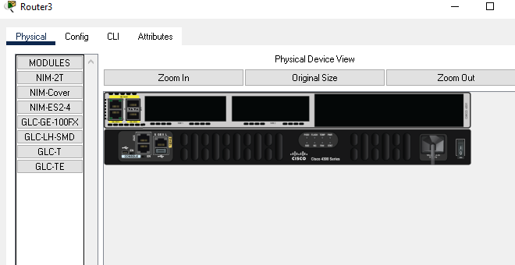

Add it

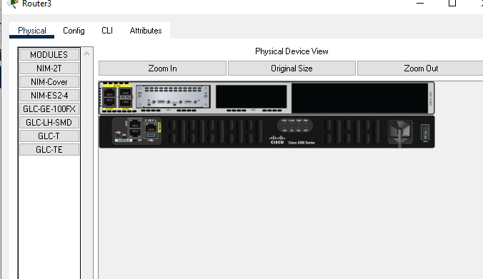

Turn on it

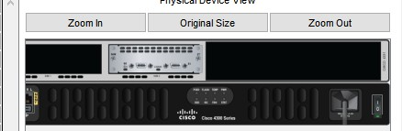

then connect it with following red wire so add it in all routers

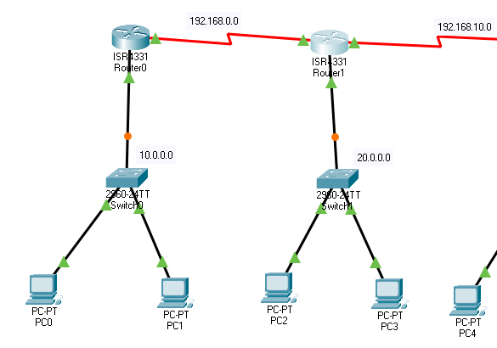

Now, next step is to give ip address for that I have already planned up that in following manner

|  |  |  |  |  |  |
| --- | --- | --- | --- | --- | --- |
| **ROUTER** | **GIGA**  **0/0/0** | **DEVICES**  **1/2** | **SERIAL**  **0/1/0** | **SERIAL**  **0/1/1** | **GIGA**  **0/0/1** |
| **ROUTER0** | 10.0.0.1 | 10.0.0.2  10.0.0.2 | 192.168.0.1 | NO | NO |
| **ROUTER1** | 20.0.0.1 | 20.0.0.2  20.0.0.3 | 192.168.0.2 | 192.168.10.1 | NO |
| **ROUTER2** | 30.0.0.1 | 30.0.0.2  30.0.0.3 | 192.168.10.2 | 192.168.20.2 | NO |
| **ROUTER3** | 40.0.0.1 | 40.0.0.2  40.0.0.3 | 192.168.20.1 | NO | NO |

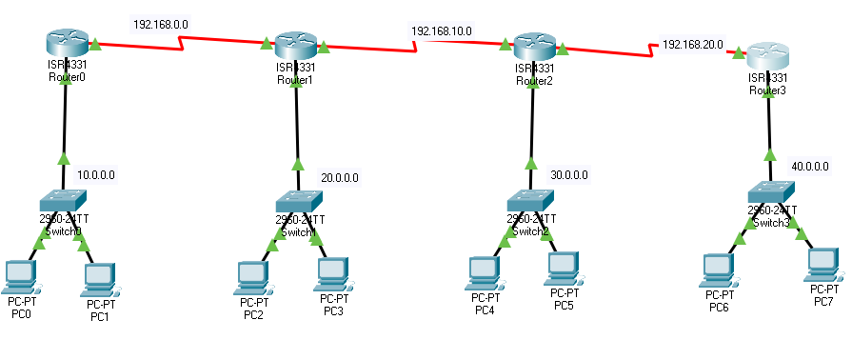

Add ip address likewise so and default gateway for each device the default gateway is giga0/0/0 device

Ip

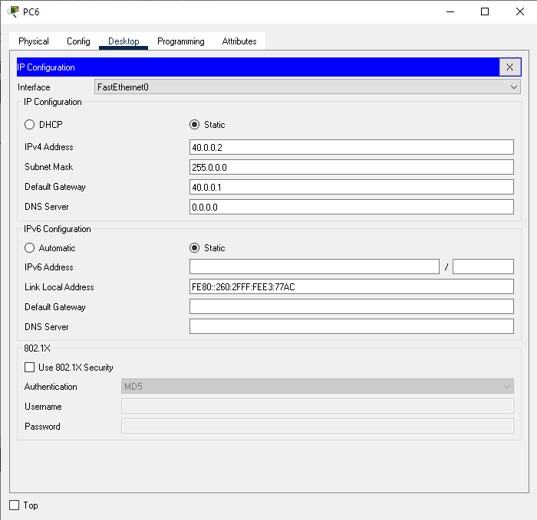

And likewise give ip address and default gateway to all pcs from table device column

Also on gigab0/0/0 and serial ports respectively Example of router 1

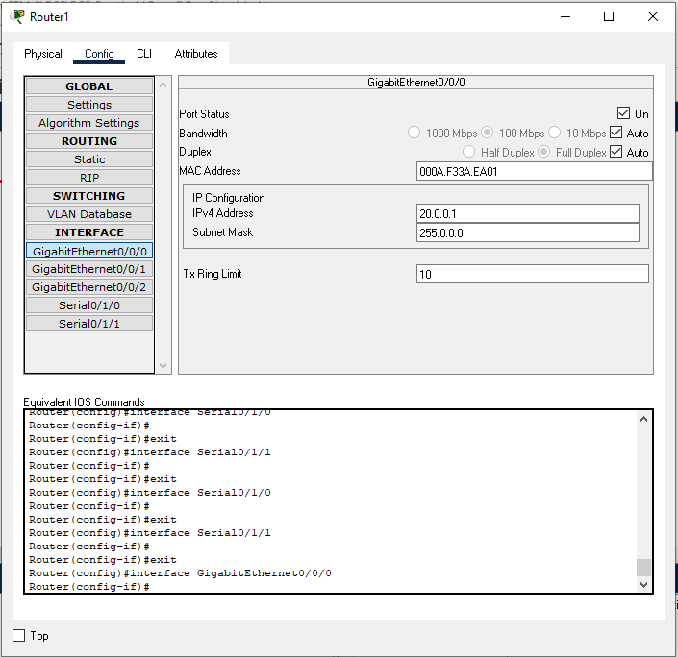

For serial0/1/0

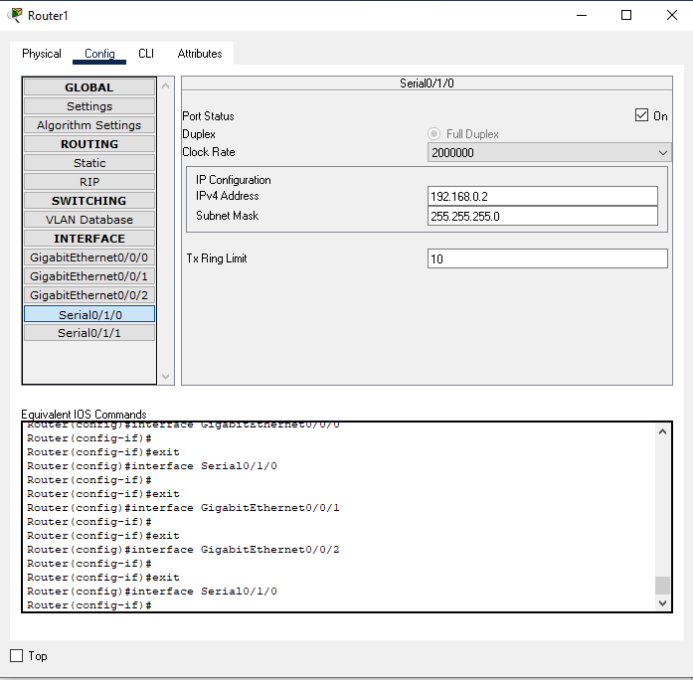

For serial0/1/1

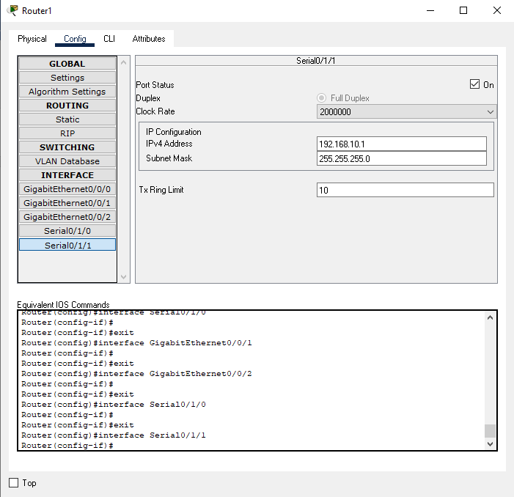

Hence give respective ips to all routers now the most important is routing table add routing table for routers

* For router 0

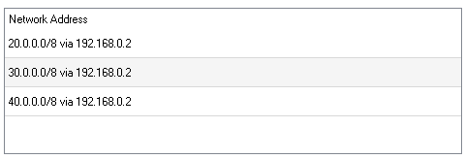

Router0 should have entries for1, 2 ,3 network.and all of them have same next hop these three are as below

So we need to add all of them to establish communication from router0 to 1,2,3 now routers have their own network too so here we need to add them also

If router0 wants to communicate with router 3 and 4 then it needs to add below ips

Hence add for other routes respectively

* For router1

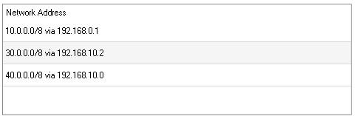

* For router 2

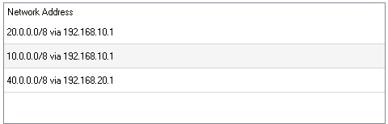

* For router 3

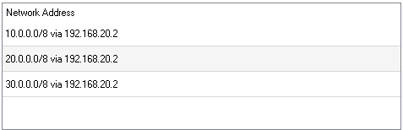

Now establish communication It should be successful

Here pc0 to pc7 the longest distance has shown successful it means routing is done properly.

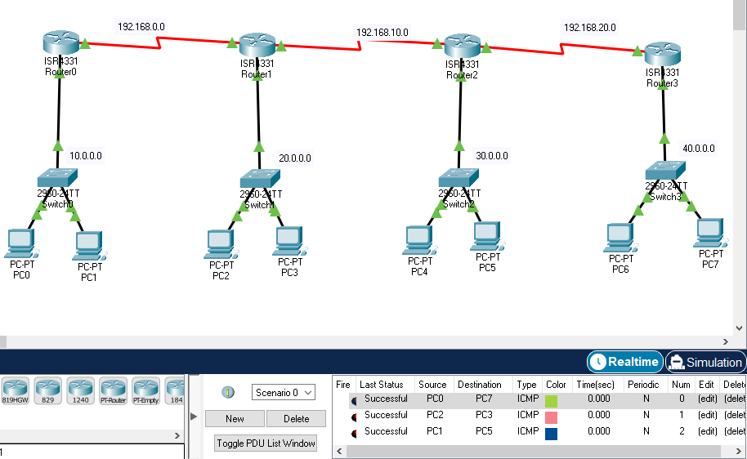

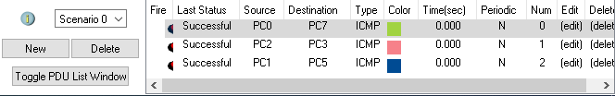

Hence, this is the end of static routing.

Let’s understand RIP

* What is RIP?

**Routing Information Protocol** (RIP) is a dynamic routing protocol where we use dynamic routing entries it means we need to add every networks with in topology on configuring single router. Same process for all routers

Step 1 first I need to remove all static enries

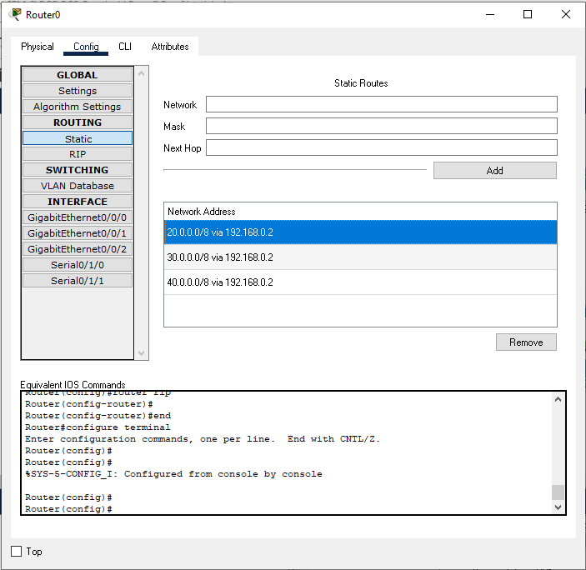

Step 2:

For that go to RIP

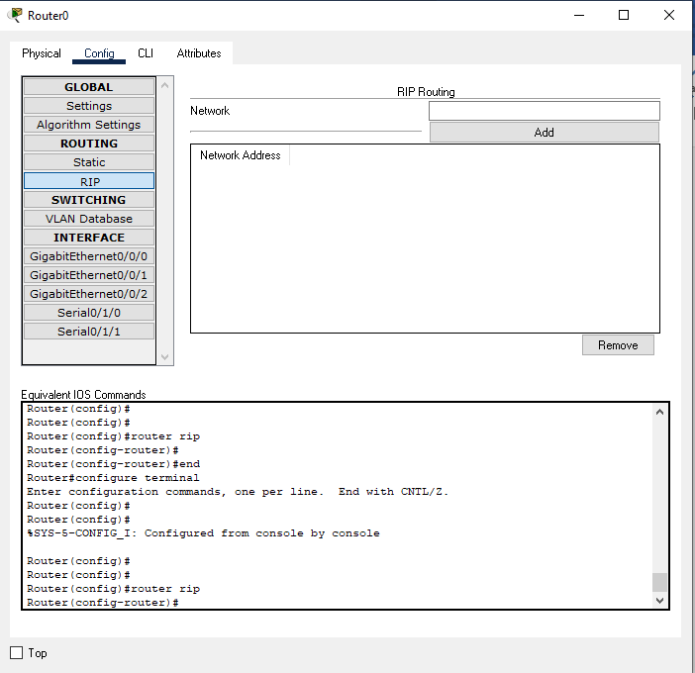

Now add all networks one by one Total 7 different networks are there

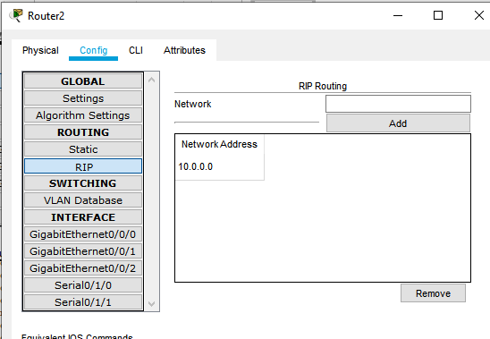

Apply add button to add all

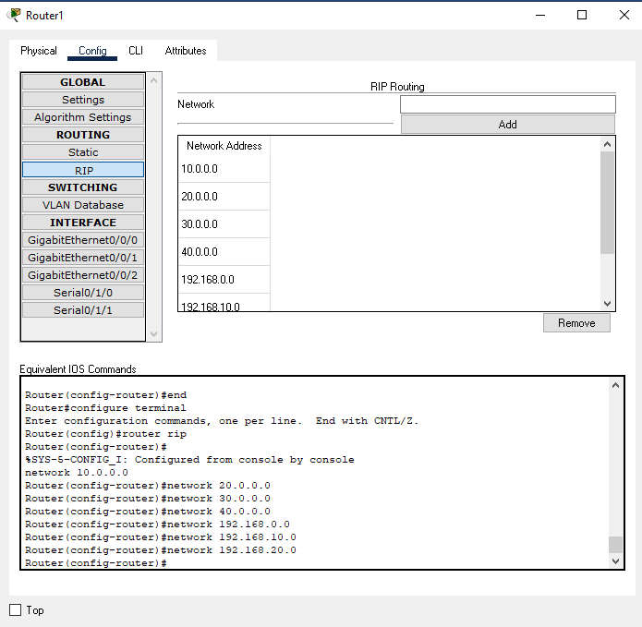

Hence we have added 7 networks

Do the same for all routers in the network Step 3: check the status

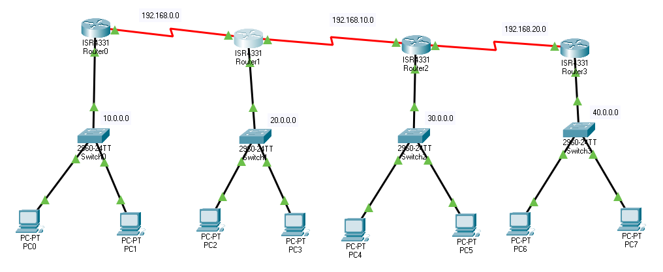

Hence it is successfully done.

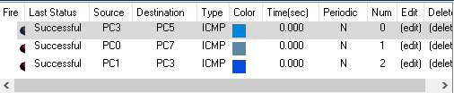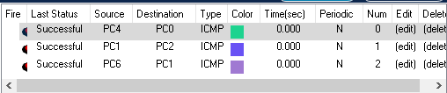

1. Disadvantage of using static routing?
   * Suitable for simple topologies not able to implement in large network because as I have taken complex topology, I need to require more time for it
   * Complexity increases at times of configuring as the network grows and manage the static configurations in large networks can become time consuming.
   * It needs to have next hop to route properly
2. Limitation of RIP?
   * According to RIP protocol
   * We can have maximum 15 hop count so it means other routers and remote routers on large network cannot connect properly
   * Other than that, it has entries for all network as soon as it gets signal it broadcast it within a network so in a way it is less secure because by crashing one router we can get entire networks ips
   * In RIP every router gets updates from nearer router so if in network no nearer routers then it will require time to get updated.
   * RIP checks its neighboring router as we have seen in above point, in every 30 seconds which will increase traffic